Date:
Exercise 1: Create a Git Repository

AIM: To create a local Git repository and initialize Git.
ALGORITHM
STEP 1: Open a terminal.
STEP 2: Create a folder for the Git practical.
STEP 3: Navigate to the created folder.
STEP 4: Initialize the Git repository using git init.
STEP 5: Check the repository status.
STEP 6: End the terminal.
TERMINAL RUN CODE
mkdir git-practical
cd git-practical
git init
git status
OUTPUT
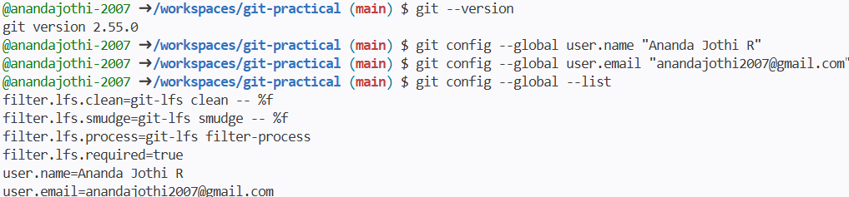

RESULT: Thus, a local Git repository was successfully created and initialized.

Date:
Exercise 2: Create a File and Track Changes
AIM: To create a file and track it using Git.
ALGORITHM
STEP 1: Open a terminal.
STEP 2: Navigate to the Git repository.
STEP 3: Create a text file and add content.
STEP 4: Check the repository status.
STEP 5: Stage the file using git add.
STEP 6: Check the staged changes.
STEP 7: End the terminal.
TERMINAL RUN CODE
cd git-practical
echo "Welcome to Git and GitHub" > message.txt
git status
git add message.txt
git status
OUTPUT
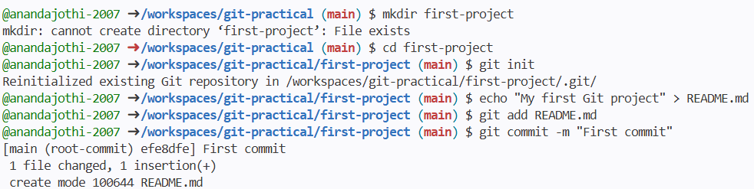

RESULT: Thus, a file was created and staged successfully for tracking by Git.

Date:
Exercise 3: Commit Changes to the Repository
AIM: To save staged changes permanently in the Git repository using git commit.
ALGORITHM
STEP 1: Open a terminal.
STEP 2: Navigate to the Git repository.
STEP 3: Create or modify a file.
STEP 4: Stage the file using git add.
STEP 5: Commit the changes with a suitable message.
STEP 6: Verify the commit using git log.
STEP 7: End the terminal.
TERMINAL RUN CODE
cd git-practical
echo "First Git commit" > commit-demo.txt
git add commit-demo.txt
git commit -m "Add first commit demo"
git log --oneline
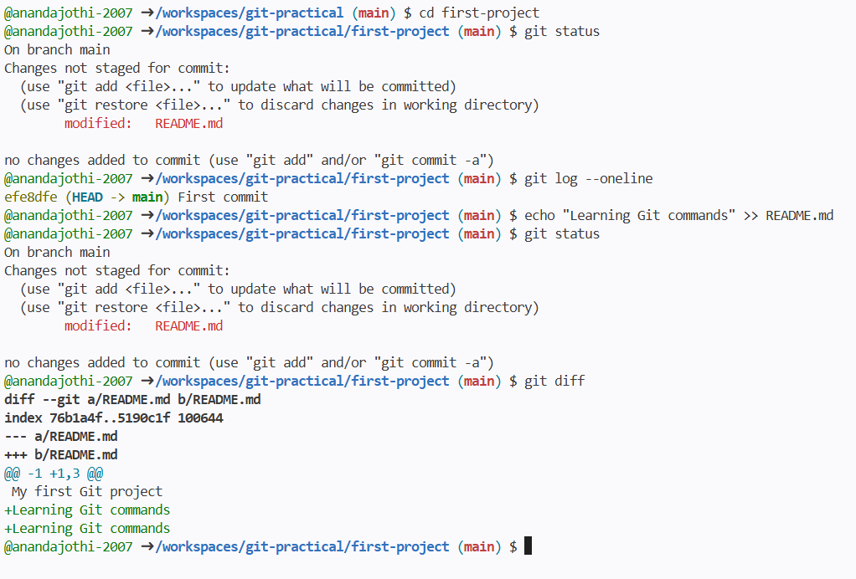
OUTPUT

RESULT: Thus, the file changes were successfully committed to the local Git repository.

Date:
Exercise 4: View Commit History
AIM: To view the commit history of a Git repository.
ALGORITHM
STEP 1: Open a terminal.
STEP 2: Navigate to the Git repository.
STEP 3: Execute git log to view the complete commit history.
STEP 4: Execute git log --oneline to view a short summary of commits.
STEP 5: Verify the commit messages and IDs.
STEP 6: End the terminal.
TERMINAL RUN CODE
cd git-practical
git log
git log --oneline
OUTPUT
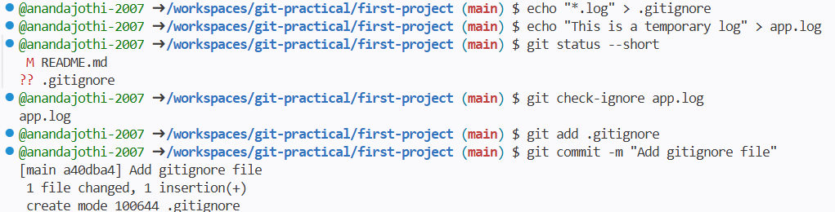

RESULT: Thus, the commit history was successfully viewed using Git commands.

Date:
Exercise 5: Undo Changes Using Git Commands
AIM: To undo unwanted file changes using Git commands such as git checkout, git reset, and git revert.
ALGORITHM
STEP 1: Open a terminal.
STEP 2: Navigate to the Git repository.
STEP 3: Create and commit a file containing original content.
STEP 4: Modify the file to demonstrate an unwanted change.
STEP 5: Use git restore to discard an unstaged change.
STEP 6: Use git reset or git revert when appropriate to undo committed changes.
STEP 7: Check the repository status and verify the result.
STEP 8: End the terminal.
TERMINAL RUN CODE
cd git-practical
echo "Original content" > undo-demo.txt
git add undo-demo.txt
git commit -m "Add original content"

echo "Unwanted change" > undo-demo.txt
git restore undo-demo.txt
cat undo-demo.txt
git status

OUTPUT
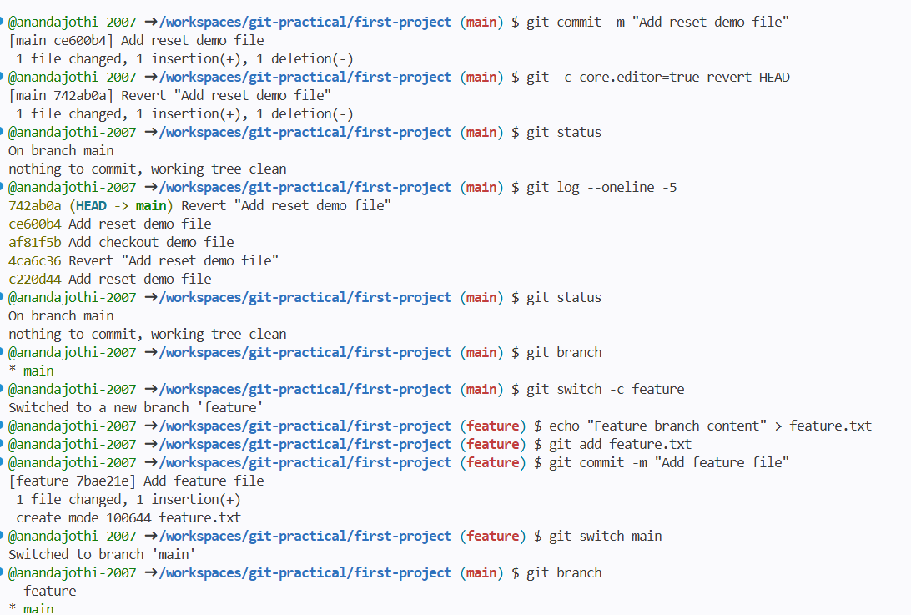
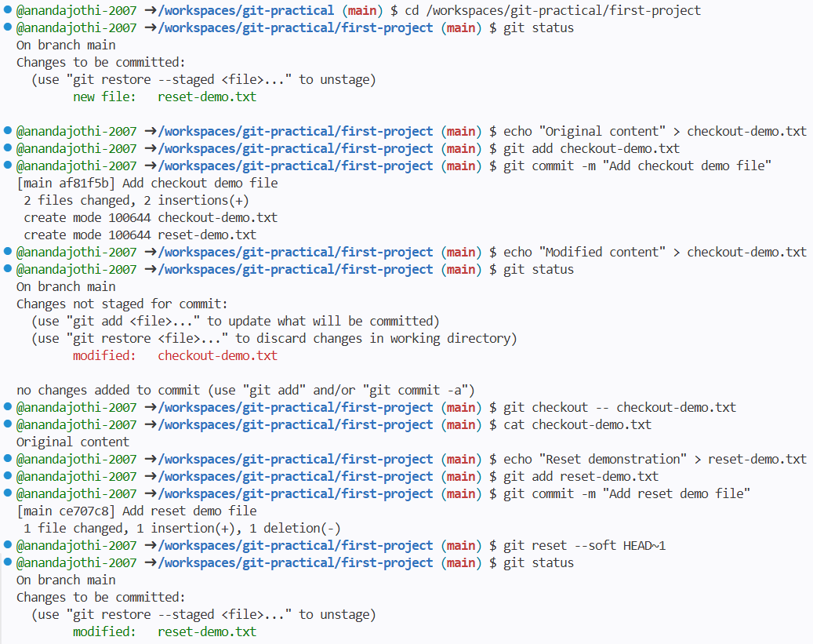

RESULT: Thus, the unstaged modification was discarded, and the original file content was restored.

Date:
Exercise 6: Create, Switch, and Delete a Branch
AIM: To create, switch between, and delete branches in Git.
ALGORITHM
STEP 1: Open a terminal.
STEP 2: Navigate to the Git repository.
STEP 3: Display the existing branches using git branch.
STEP 4: Create a new branch using git branch.
STEP 5: Switch to the new branch using git switch.
STEP 6: Verify the current branch.
STEP 7: Switch back to the main branch.
STEP 8: Delete the new branch after switching away from it.
STEP 9: End the terminal.
TERMINAL RUN CODE
cd git-practical
git branch
git branch feature-demo
git switch feature-demo
git branch
git switch main
git branch -d feature-demo
git branch
OUTPUT
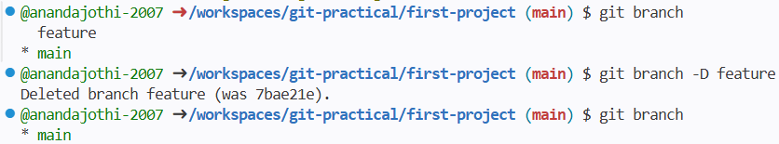
RESULT: Thus, a new branch was created, selected, and deleted successfully.
Date:
Exercise 7: Resolve a Merge Conflict
AIM: To identify and resolve a merge conflict between two Git branches.
ALGORITHM
STEP 1: Open a terminal.
STEP 2: Navigate to the Git repository.
STEP 3: Create a new branch for the conflicting changes.
STEP 4: Modify the same file on the new branch and commit the change.
STEP 5: Switch to the main branch and modify the same file differently.
STEP 6: Commit the main branch change.
STEP 7: Merge the feature branch into the main branch.
STEP 8: Identify the merge conflict and edit the file to retain the required content.
STEP 9: Stage the resolved file and commit the merge resolution.
STEP 10: Verify the final file content and end the terminal.
TERMINAL RUN CODE
The following is a sample demonstration. Start with a clean repository and use a separate practice file.
cd git-practical
echo "Welcome to Git" > conflict-demo.txt
git add conflict-demo.txt
git commit -m "Add conflict demo file"

git switch -c feature-conflict
echo "Feature branch content" > conflict-demo.txt
git add conflict-demo.txt
git commit -m "Update file in feature branch"

git switch main
echo "Main branch content" > conflict-demo.txt
git add conflict-demo.txt
git commit -m "Update file in main branch"

git merge feature-conflict
If a conflict occurs, edit conflict-demo.txt and remove the conflict markers (<<<<<<<, =======, >>>>>>>). Keep the content you want, then run:
git add conflict-demo.txt
git commit -m "Resolve merge conflict"
cat conflict-demo.txt
git status
OUTPUT
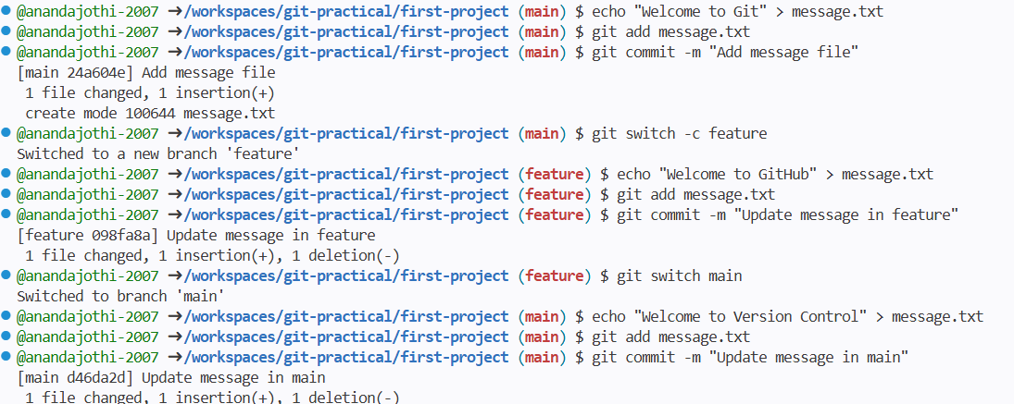
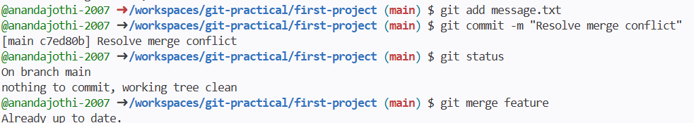

RESULT: Thus, a merge conflict was resolved and the resulting changes were committed successfully.

Date:
Exercise 8: Store and Restore Changes Using Git Stash
AIM: To temporarily save uncommitted changes using git stash and restore them later.
ALGORITHM
STEP 1: Open a terminal.
STEP 2: Navigate to the Git repository.
STEP 3: Create or modify a file with some content.
STEP 4: Save the changes temporarily using git stash.
STEP 5: Verify that the working directory is clean.
STEP 6: Restore the saved changes using git stash pop.
STEP 7: Display the file content and verify the restored changes.
STEP 8: End the terminal.
TERMINAL RUN CODE
cd git-practical
echo "Original content" > notes.txt
git add notes.txt
git commit -m "Add original notes"

echo "Temporary work" >> notes.txt
git stash push -m "Save temporary work"
git status
git stash pop
cat notes.txt

OUTPUT
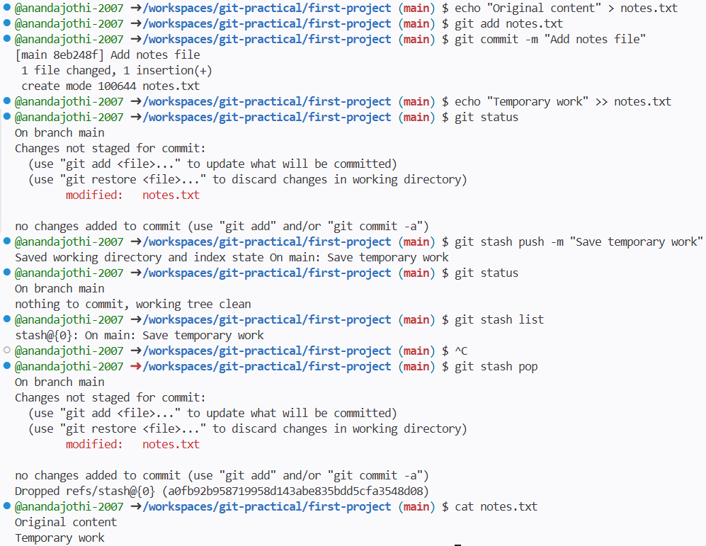

RESULT: Thus, uncommitted changes were temporarily stored and restored successfully.

Date:
Exercise 9: Configure a Remote Repository
AIM: To connect a local Git repository with a remote repository hosted on GitHub.
ALGORITHM
STEP 1: Open a terminal.
STEP 2: Navigate to the local Git repository.
STEP 3: Check whether a remote repository is already configured.
STEP 4: Add the GitHub repository URL as the origin remote if it is not configured.
STEP 5: Verify the remote URL using git remote -v.
STEP 6: End the terminal.
TERMINAL RUN CODE
cd /workspaces/git-practical
git remote -v
If origin is not configured, add it:
git remote add origin https://github.com/anandajothi-2007/git-practical.git
git remote -v
If origin already exists, do not add it again.
OUTPUT

RESULT: Thus, the local repository was connected to the remote GitHub repository and the remote configuration was verified.

Date:
Exercise 10: Clone, Push, and Pull Changes
AIM: To clone a remote repository, push local changes to GitHub, and pull remote changes to the local repository.
ALGORITHM
STEP 1: Open a terminal.
STEP 2: Navigate to the required workspace directory.
STEP 3: Clone the remote repository using git clone.
STEP 4: Navigate into the cloned repository.
STEP 5: Create a file containing sample content.
STEP 6: Stage and commit the file.
STEP 7: Push the commit to GitHub using git push.
STEP 8: Pull the latest remote changes using git pull.
STEP 9: Verify the file and repository status.
STEP 10: End the terminal.
TERMINAL RUN CODE
Use a different folder name if git-practical already exists in your current directory.
cd /workspaces
git clone https://github.com/anandajothi-2007/git-practical.git
cd git-practical
echo "Push and pull practical" > push-pull-demo.txt
git add push-pull-demo.txt
git commit -m "Add push pull demo"
git push origin main
git pull origin main
cat push-pull-demo.txt

OUTPUT
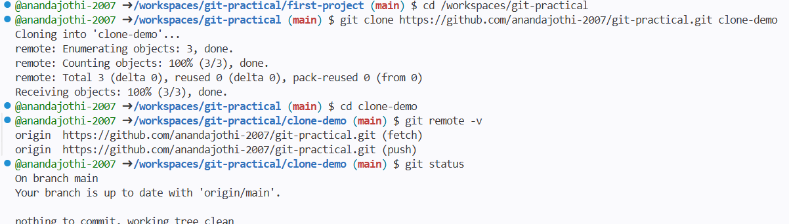

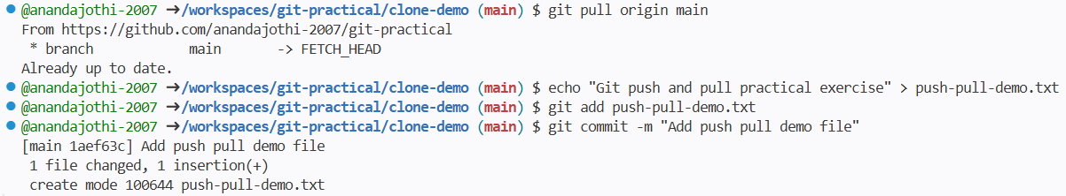

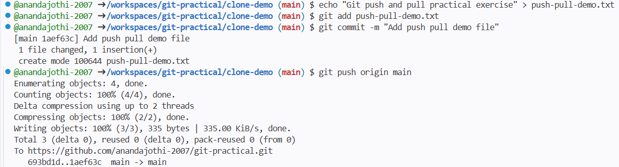

RESULT: Thus, the repository was cloned, local changes were committed and pushed, and remote changes were synchronized using Git.

Date:
Exercise 11: Fork a Repository and Create a Pull Request
AIM: To fork another user's GitHub repository, make a change, and submit a pull request.
ALGORITHM
STEP 1: Open a web browser and sign in to GitHub.
STEP 2: Open the repository octocat/Hello-World.
STEP 3: Click the Fork option to create a copy under your GitHub account.
STEP 4: Open the forked repository.
STEP 5: Edit the README.md file and add the practical exercise documentation.
STEP 6: Commit the changes to the forked repository.
STEP 7: Select Contribute or Compare & pull request.
STEP 8: Enter a suitable pull request title and description.
STEP 9: Create the pull request and verify its status.
STEP 10: End the browser session.
TERMINAL RUN CODE
This exercise was performed using the GitHub website, so terminal commands are not required. The equivalent command to clone your fork is:
git clone https://github.com/anandajothi-2007/Hello-World.git
cd Hello-World
git status

OUTPUT
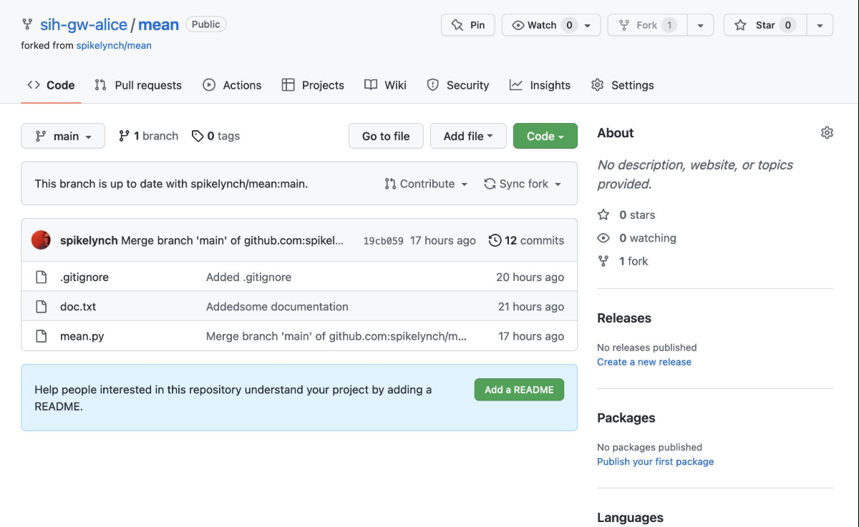
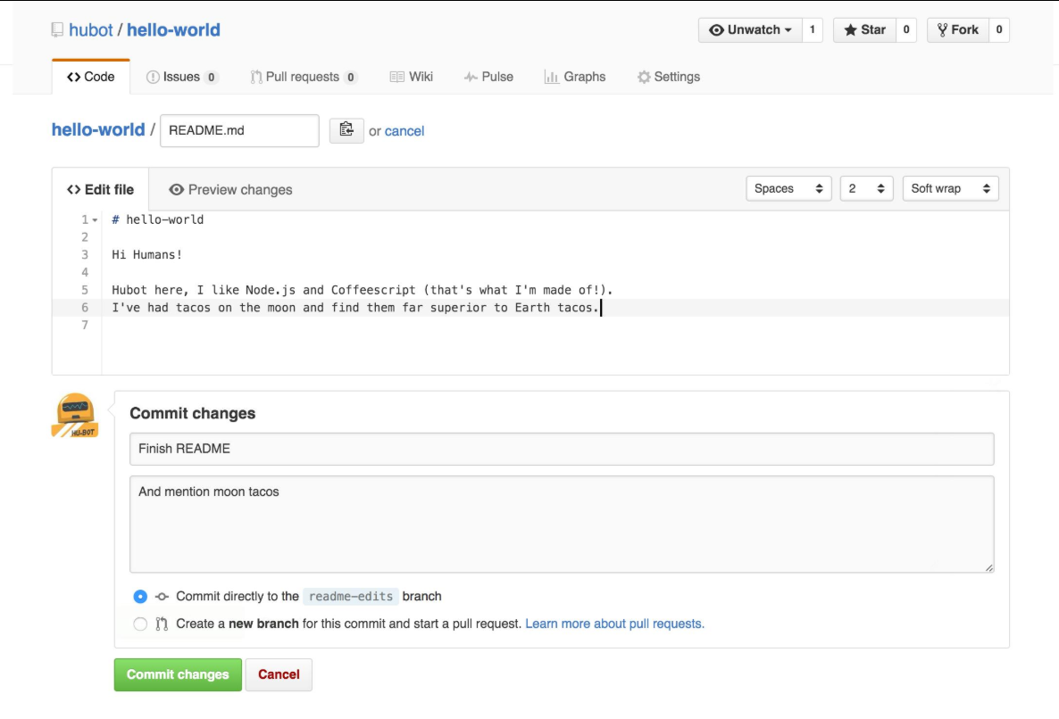

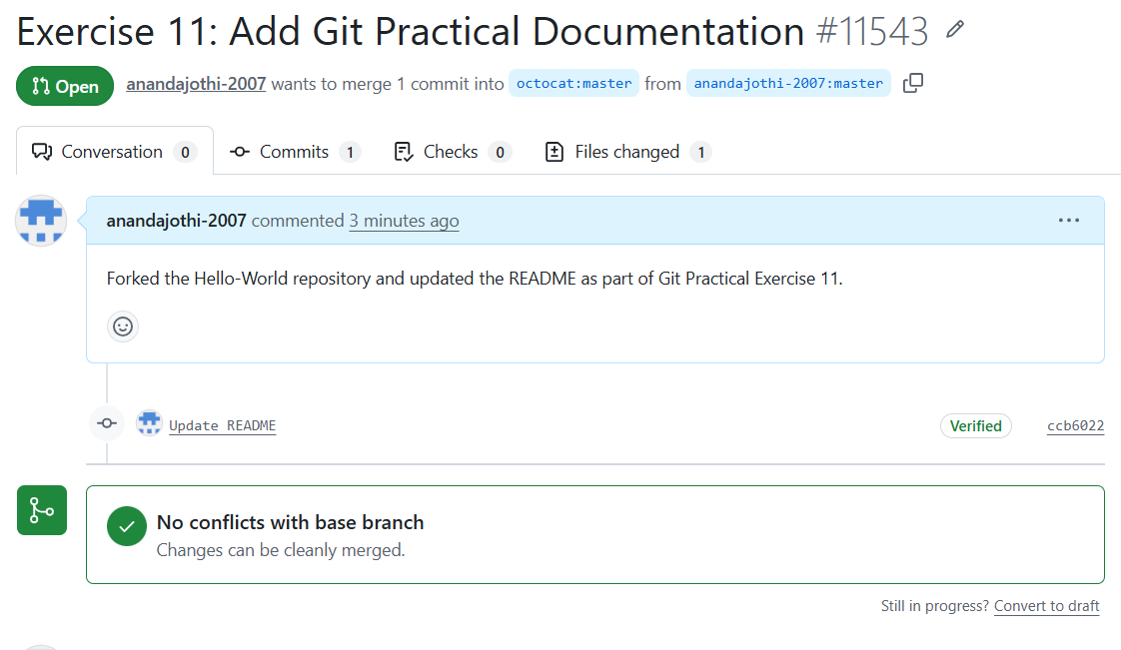

RESULT: Thus, a repository was forked, the README file was updated, and a pull request was submitted successfully.

Date:
Exercise 12: Collaborative Editing with Multiple Contributors
AIM: To collaborate with another contributor by sharing a GitHub repository and synchronizing changes.
ALGORITHM
STEP 1: Open a terminal.
STEP 2: Navigate to the local Git repository.
STEP 3: Create a collaboration file with an initial message.
STEP 4: Stage, commit, and push the file to GitHub.
STEP 5: Add another GitHub user as a collaborator through repository settings.
STEP 6: Ask the collaborator to edit the file and commit the changes.
STEP 7: Pull the latest changes from the remote repository.
STEP 8: Display the file to verify both contributors' content.
STEP 9: End the terminal.
TERMINAL RUN CODE
The initial file was created in the practical repository as follows:
cd /workspaces/git-practical
echo "Collaborative editing practical - Exercise 12" > collaboration.txt
git add collaboration.txt
git commit -m "Add collaborative editing exercise"
git push origin main
After the collaborator commits and pushes their contribution, run:
git pull origin main
cat collaboration.txt
git log --oneline -5

OUTPUT
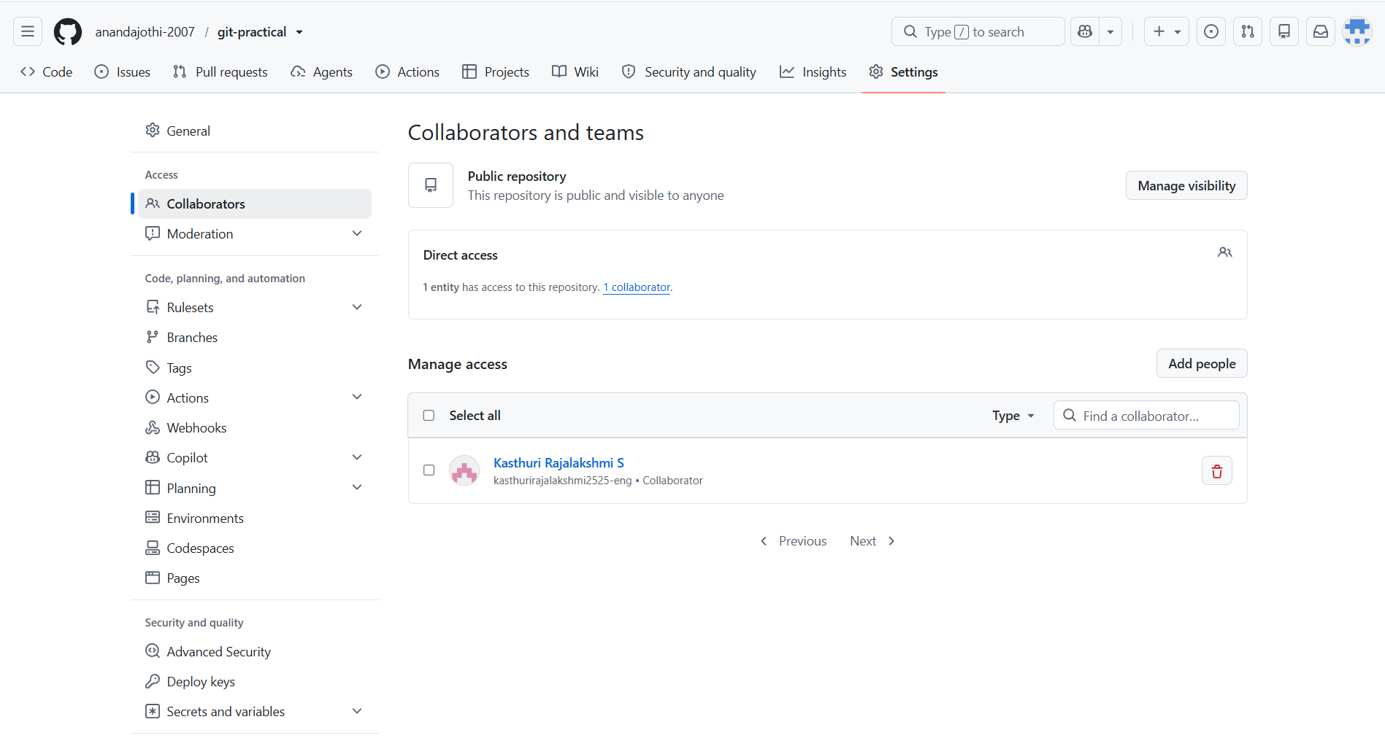

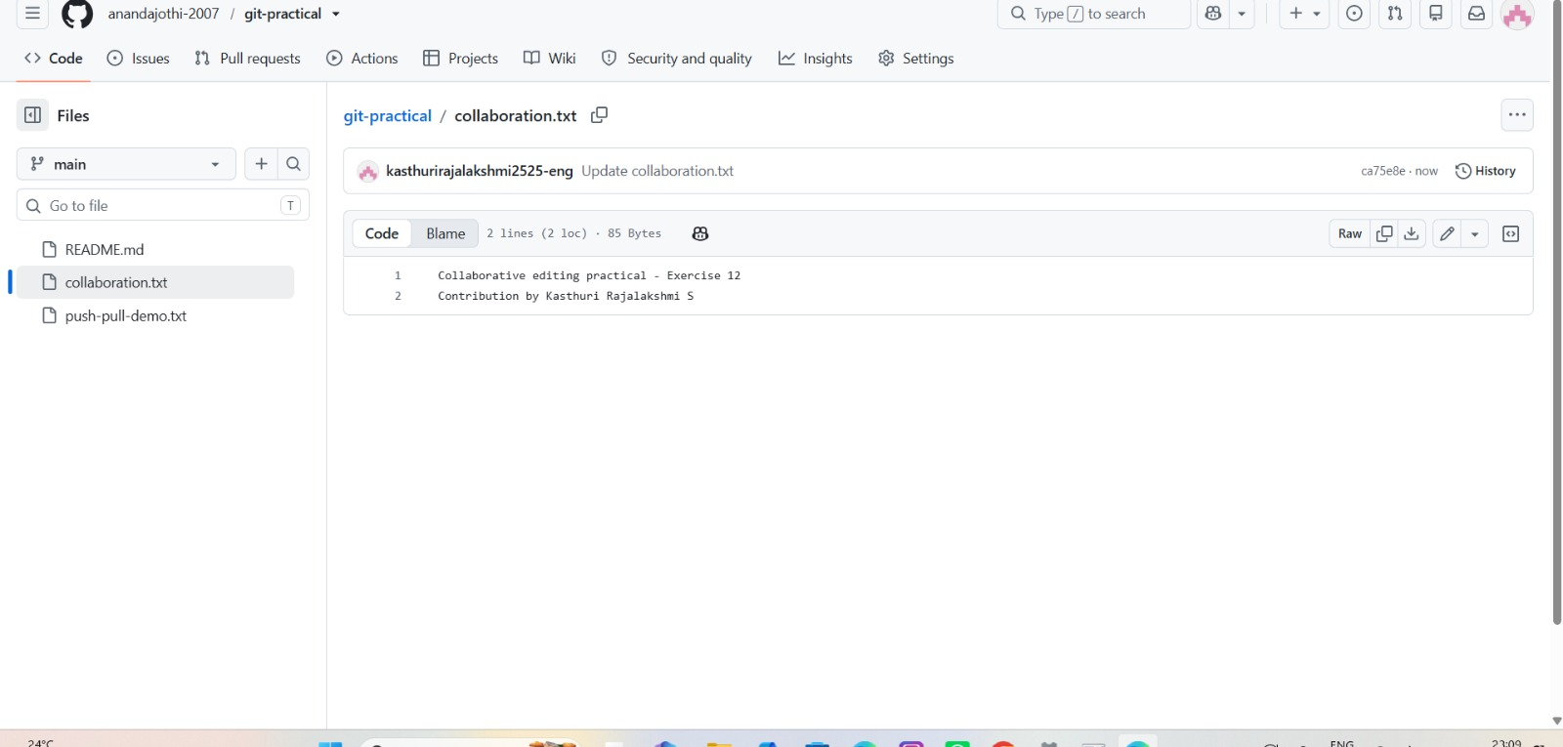

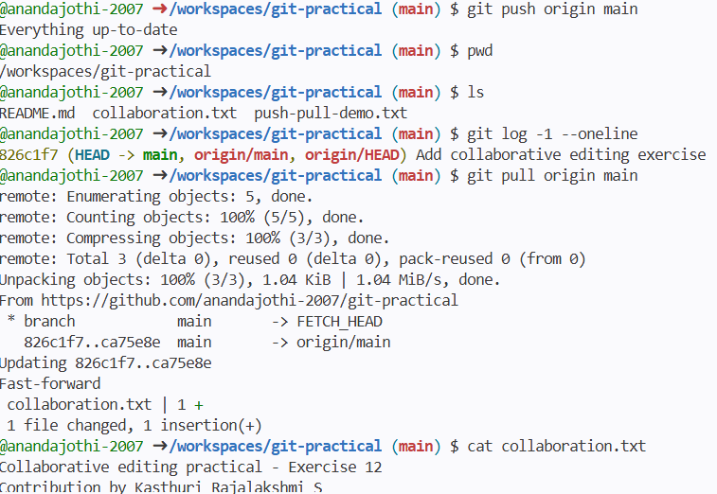

RESULT: Thus, collaborative editing was performed by sharing a repository, committing changes from another contributor, and synchronizing the updates with git pull.

Date:
Exercise 13: Manage GitHub Issues and Project Boards
AIM: To create GitHub Issues and organize practical tasks using a GitHub Projects board.
ALGORITHM
STEP 1: Open a web browser and sign in to GitHub.
STEP 2: Open the repository anandajothi-2007/git-practical.
STEP 3: Navigate to the Issues tab.
STEP 4: Click New issue and enter a suitable title and description.
STEP 5: Create the issue and note its issue number.
STEP 6: Open the Projects section and create a project named Git Practical Task Tracker if it does not already exist.
STEP 7: Add task cards such as Complete Git documentation, Verify collaborative editing, and Review GitHub Issues.
STEP 8: Link the created issue to the project using the issue's Projects section or by adding the issue from the project board.
STEP 9: Verify that the issue and task cards appear in the project.
STEP 10: End the browser session.
TERMINAL RUN CODE
This exercise is mainly performed through the GitHub website. To open the repository's Issues page from a terminal, use:
echo "Open the GitHub Issues page in your browser:"
echo "https://github.com/anandajothi-2007/git-practical/issues"
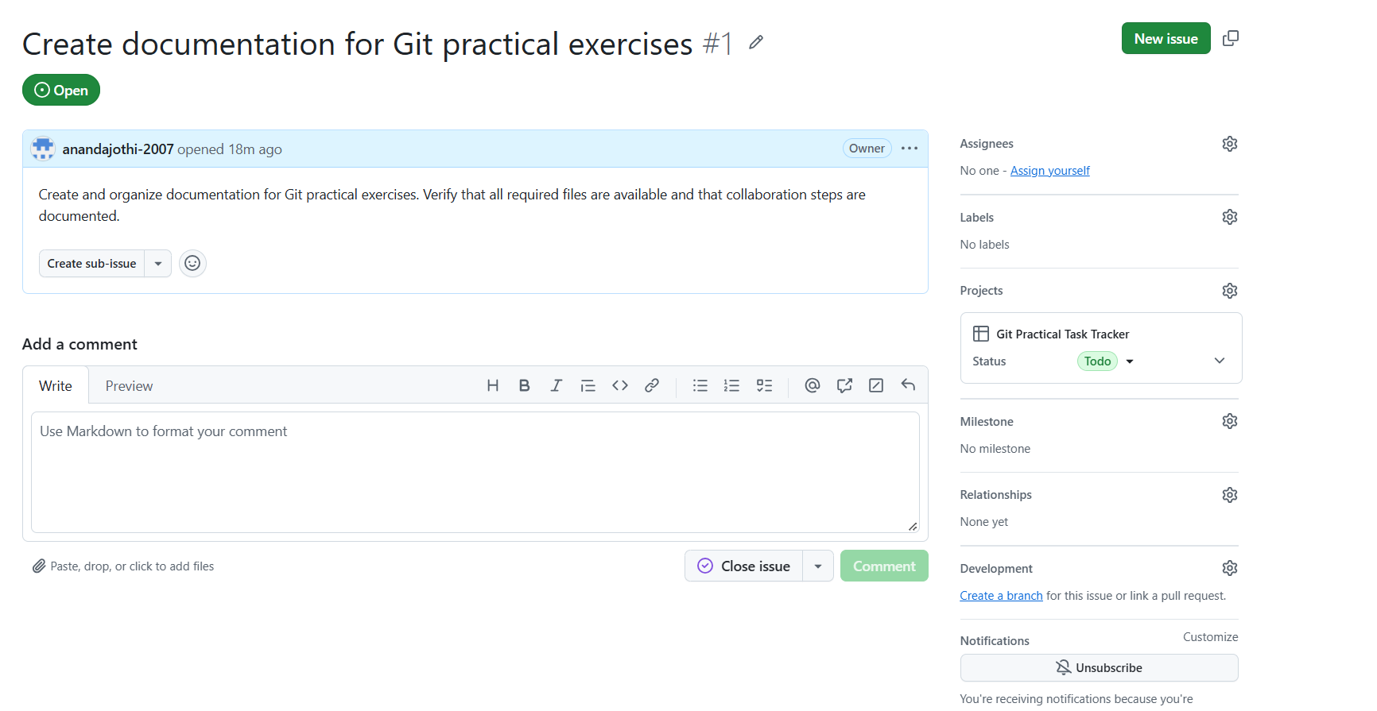
OUTPUT

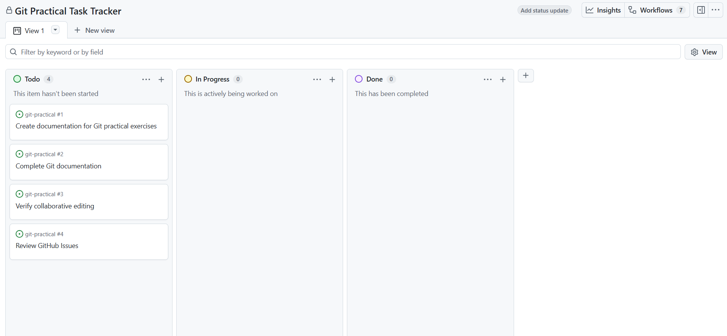
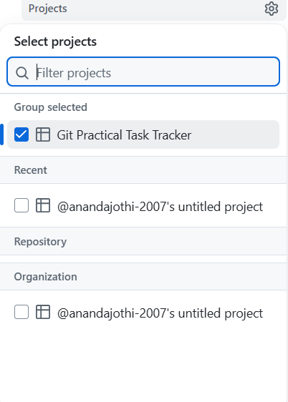
RESULT: Thus, GitHub Issues were used to track work, and a project board was used to organize and monitor the practical tasks.

